**ASSIGNMENT FORMAT**

|  |  |  |  |
| --- | --- | --- | --- |
| **COURSE** |  | **ASSIGNMENT NO** |  |
| **MODULE** |  | **ASSIGNMENT DATE** |  |
| **STUDENT NAME** |  | **SUBMISSION DATE** |  |

**Q1.** Explain Routing and various types of routing with their advantages?

**Ans:**

*“Answer in points along with the advantages”*

**Q2.**  Configure a network with 4-6 routers and do static-routing.

*“Write down your observation”*

*“Attach the screenshot of your findings”*

**Q3.** Connect the network as given in the below diagram



Configure the Network using static first and then OSPF

**!!IMPORTANT!!**

**For R2**

1. **Select only 2811 Router**
2. **Go to>>Physical>>switch-off Router Power**
3. **Select under modules>> NM-2FEW Module**
4. **Drag and drop additional interface in empty space.**
5. **Power ON the Router, now you can configure 3 interfaces in Router**

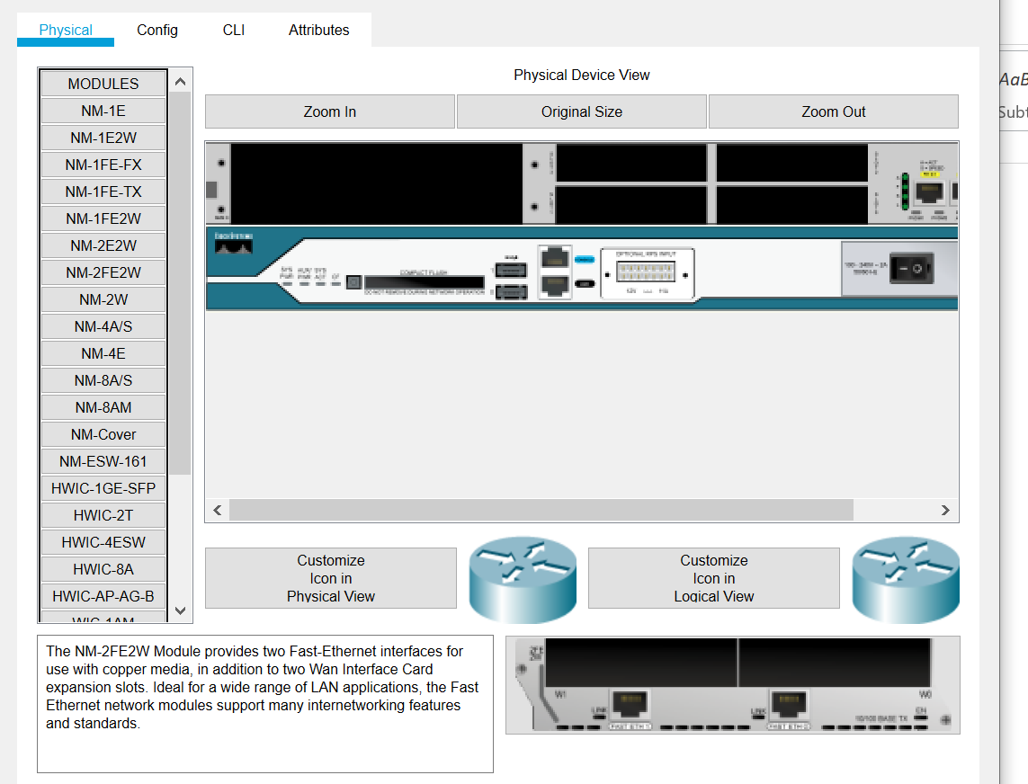

Additional Interfaces

Drop Here

Power ON/OFF

**Solution:**

1. **Draw the Network and show the topology in Packet Tracer**

*“Attach the screenshot of Topology”*

1. **Assign the IP’s to all devices as per the network topology**

*“Attach the screenshot of one PC and all Router Interface Configuration”*

1. **Configure the Static route in each router**

*“Attach the screenshot of all Router Interface Configuration”*

1. **Ping 172.16.1.2 to 172.16.2.3 and 172.16.1.3 to 172.16.3.2**

*“Attach the screenshot of both successful ping results”*

1. **Enter the following commands to configure the dynamic routing using OSPF routing commands**

**Go to Router >>CLI Press ENTER**

**On R1,**

R1(config)# router ospf 1

R1(config-router)# network 172.16.1.0 0.0.0.255 area 0

R1(config-router)# network 10.0.1.0 0.255.255.255 area 0

*“Attach the screenshot of Router Configuration”*

**Check the router configuration using following**

R1# show ip ospf interface

*“Attach the screenshot of Result”*

R1# show ip protocols

*“Attach the screenshot of Result”*

R1# show ip route

*“Attach the screenshot of Result”*

**On R2,**

R2(config)# router ospf 1

R2(config-router)# network 172.16.2.0 0.0.0.255 area 0

R2(config-router)# network 10.0.1.0 0.255.255.255 area 0

R2(config-router)# network 10.0.2.0 0.255.255.255 area 0

*“Attach the screenshot of Router Configuration”*

**On R3,**

R3(config)# router ospf 1

R3(config-router)# network 172.16.3.0 0.0.0.255 area 0

R3(config-router)# network 10.0.2.0 0.255.255.255 area 0

*“Attach the screenshot of Router Configuration”*

1. **Establish the connectivity by sending ping packets from one Network to another**

*“Attach the screenshot of your findings”*